Kids’ Community Theater 2020!
Peace in the Kingdom by Cynthia and Michael Marion
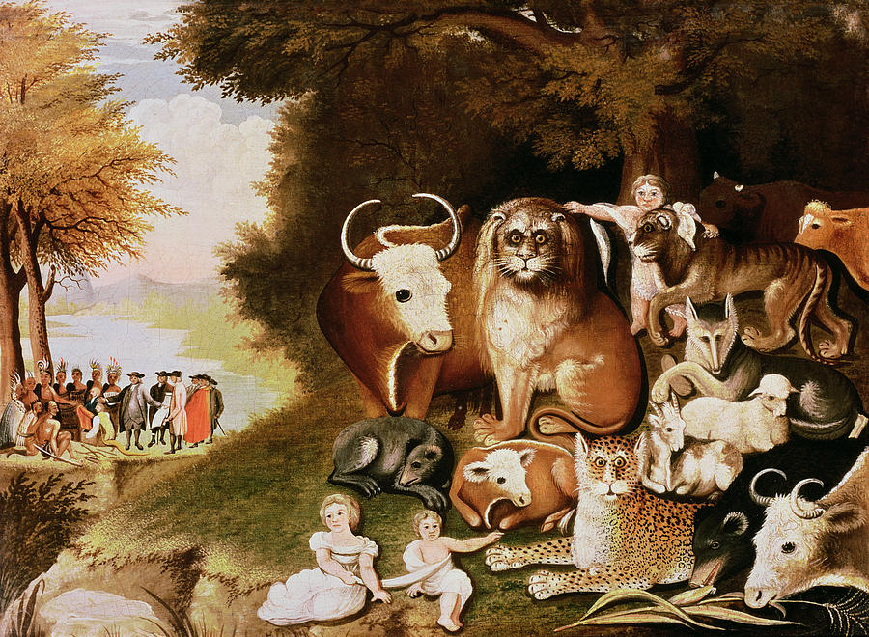
Painting: The Peaceable Kingdom by Edward Hicks
Our musical this year will be this painting—come alive!!
WHAT:
Weekly musical theater rehearsals
and TWO performances!

WHO: All K-5th graders are welcome!

WHERE: Sunnyside Mennonite Church
23786 Sunnyside Ave, Elkhart, IN 46516

WHEN: Wednesdays, January 8 – February 26
5:30 pm, Meal for all KCT households
6:15-7:30 pm, Rehearsal
(January 25, 9 am: Make-up rehearsal if needed)

PERFORMANCES: 3 pm Saturday, February 29
6 pm Sunday, March 1

If your child plans to participate, please email amykratzer@gmail.com
Or call Sunnyside! (574) 875-7790
Kids’ Community Theater 2020!
Peace in the Kingdom by Cynthia and Michael Marion
Painting: The Peaceable Kingdom by Edward Hicks
Our musical this year will be this painting—come alive!!
WHAT:
Weekly musical theater rehearsals
and TWO performances!

WHO: All K-5th graders are welcome!

WHERE: Sunnyside Mennonite Church
23786 Sunnyside Ave, Elkhart, IN 46516

WHEN: Wednesdays, January 8 – February 26
5:30 pm, Meal for all KCT households
6:15-7:30 pm, Rehearsal
(January 25, 9 am: Make-up rehearsal if needed)

PERFORMANCES: 3 pm Saturday, February 29
6 pm Sunday, March 1

If your child plans to participate, please email amykratzer@gmail.com
Or call Sunnyside! (574) 875-7790

