Soul Tending
Journey into the Heart of Sabbath

Join us for a community evening of Summer Solstice reflection and Soul Tending

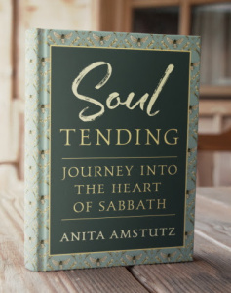
Where: Pathways Retreat Center, 309 ½ Hackett Rd.
When: Wednesday June 20, 7-8:30pm
Music, poetry, prayer and sharing

Anita Amstutz describes Soul Tending as a spiritual biography. It is “a story of my own wrestling with balance in my work life…how I found the Sabbath welcome of ‘ceasing work’ to be a solace in that dry, droughty space between creativity and overwork/soul weariness”. We live in hungry times of economic uncertainty, fear, violence, division, and social chaos. What is needed for times such as these is a heart full of courage and wisdom grounded in compassion and resilience and recovering a slower rhythm in today’s world.

Books will be available for purchase and signing

Amazon, Barnes and Noble, Indie Books
Visit https://afamstutz.com for more information.

